Sithandiwe Mtshali
ST10477753
WEDE5020
Summative POE

ST10477753
Sithandiwe Mtshali
Web Development
WEDE5020
POE Part 1

Table of Contents
Table of Contents
Website Choice 3
Organization Description 3
Reasons of Website Choice 3
Goals 3
Objectives 4
Timeline and Milestones 4-5
Budget 5
Mission Statement 5
Vision Statement 5
Website Assets 6-7
Website Pages and Content 8
Home 8
About 8
Services 9
Knowledge Base 9
Ticket System 10
Contact 11
Home Page List 11
About Page List 12
Services Page List 12
Knowledge Base Page List 12
Ticket System Page List 13
Contact Page List 13
Site Map 13
References 14

Website Choice
1. Organization Description
Lionel’s Tech Support is an imagined IT support company that focuses on assisting individuals and small businesses with everyday technical problems. The organization provides troubleshooting services, user guidance, and digital support through an interactive website platform. The platform allows users to access a knowledge base for common issues or submit support tickets for more complex problems.

2. Reasons for Website Choice
The decision to create Lionel’s Tech Support was based on the need to solve real-life technology problems that many people experience daily. Technology is widely used in modern society; however not all users have the knowledge or skills to resolve technical issues independently.
Many individuals, students and small businesses often face challenges such as Wi-Fi connectivity issues, malfunctioning printers, forgotten passwords, and slow computer performance. These issues, although common, can cause frustration, reduce productivity and waste valuable time
This website was chosen to provide a structured and accessible platform where users can find quick solutions or request assistance without relying on unverified sources or expensive technicians

3. Goals
The main goal of the website is to provide a reliable and user-friendly platform for technical support. It aims to simplify problem-solving by offering clear guidance and accessible assistance to users with varying levels of technical knowledge.
Another goal is to improve customer experience by ensuring that support services are organized, efficient, and easy to access through a centralized system.

4. Objectives
- To develop an interactive website with a functional knowledge base
- To implement a ticketing system that assigns unique IDs to user issues
- To provide step-by-step solutions for common technical problems.
- To improve response time and communication between users and support agents
- To ensure the website is simple, clear, and easy to navigate.

5. Timeline and Milestones
The development of the Lionel’s Tech Support website took place over three weeks, with each week dedicated to specific stages of the project to ensure steady progress and successful completion.

- Week 1-3: Planning and Research
During the first week, the main idea of the website was established and explored in detail. Research was carried out to understand common technical issues faced by users, and a basic structure for the website was outlined. Important features, such as knowledge base and ticketing system, were also identified and planned.

- Week 4-6: Design and Development
In the second week, the visual layout and structure of the website were created. Key pages including Home, About, Services, Knowledge Base, and Contact pages, were developed. In addition, relevant website assets such as images and branding elements were incorporated, while core features like the support system were built.

- Week 7-10: Testing and Finalization
The final week focused on reviewing the website to detect and correct any errors. Adjustments were made to improve usability and overall performance. After completing the testing process, the websites were finalized and prepared for submission or launch.
6. Budget
The estimated budget for developing Lionel’s Tech website is as follows
Domain Registration | R150 – R300 per year
Web Hosting | R1000 – R2000 per year
Design and Branding | R500 – R1000
Maintenance and Updates | R500 annually
Total Estimated Budget | R2150 – R5300

7. Mission Statement
Our mission is to provide reliable, affordable, and easy-to-understand technical support services that help customers solve their IT problems efficiently and confidently.

8. Vision Statement
Our vision is to become a trusted and recognized tech support service known for professionalism, innovation, and excellent customer service.
The website supports this vision by offering a user-friendly, interactive, and informative platform. The knowledge base promotes user learning, while the ticket system ensures efficiency and organization.

Website Assets

Source: icons8

Source: Unsplash

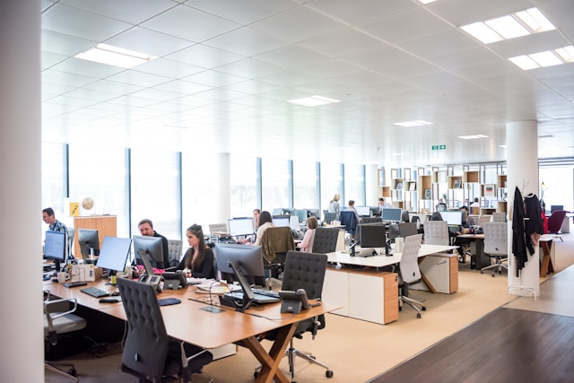
Source: Unsplash

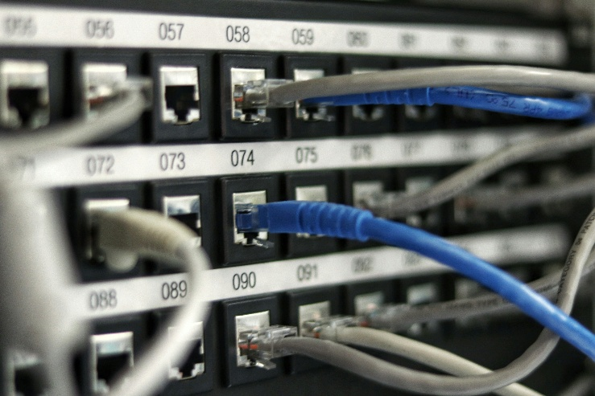
Source: Unsplash
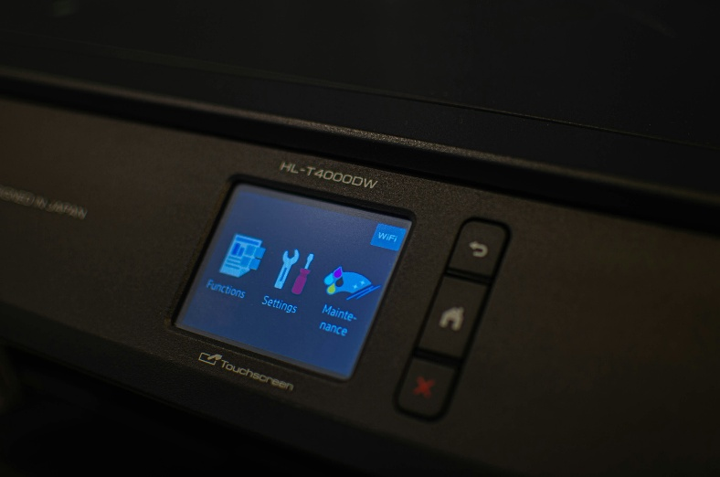

Source: Unsplash

Website Pages and Content
A. Home
The Home page of Lionel’s Tech Support is designed to welcome users and introduce them to the purpose of the website. The page uses a color scheme of green, blue and white, which creates a modern and professional appearance. At the top of the page there is a logo, a slogan, and a navigation bar that allows users to move easily to other pages such as About, Services, Knowledge Base, Ticket System, and Contact.
The Home page also contains a large full-width image that shows a technology support environment such as help desk or IT technicians working. This image helps users understand the purpose of the business immediately.
Basic contact information is included so users can easily reach the support team if needed. At the bottom of the page, there is a footer that contains copyright information and the year. Overall, the Home page is simple. User friendly and designed to guide users through the website easily.

B. About
The About page of Lionel’s Tech Support provides more detailed information about the organization and its purpose. The page follows the same color scheme of green, blue and white to keep the design consistent across the website. A navigation bar is included at the top, allowing users to move easily to other pages such as Home, Services, Knowledge Base, Ticket System, and Contact.
This page includes a full-width image that represents a professional IT environment, such as a team working with computers or assisting clients. This image helps create a sense of trust and shows users what the organization is about.
The About page explains the main activities of Lionel Tech Support, including helping users solve technical problems, providing IT support, and assisting both individuals and small businesses. It also includes basic contact information so users can reach out if they need help.
At the bottom of the page, there is a footer that contains copyright information and the year. Overall, the About page helps users understand the background and purpose of the organization while maintaining a clean and professional layout.

C. Services
The Services page of Lionel Tech Support explains the different types of technical support offered by the organization. The page uses the same green, blue, and white color scheme to keep the website consistent and professional. A navigation bar is included at the top so users can easily move to other pages such as Home, About, Knowledge Base, Ticket System, and Contact.
The page clearly lists the main services provided, such as computer troubleshooting, network support, printer setup, and password recovery. These services are organized in a simple and structured way, making it easy for users to understand what kind of help is available.
Icons and images may be used to make the page more visually appealing and easier to follow. Each service includes a short description to explain how the support team can assist users with their technical problems.
At the bottom of the page, there is a footer that includes contact details and copyright information. Overall, the Services page is designed to clearly show what the organization offers and help users quickly find the support they need.

D. Knowledge Base
The Knowledge Base page of Lionel Tech Support is designed to help users solve common technical problems on their own without needing contact support. The page follows the same green, blue, and white color scheme to keep the website consistent and professional. A navigation bar is included at the top to allow users to easily move between different pages.
This page contains different troubleshooting topics, such as Wi-Fi connection issues, slow computer performance, and printer problems. Each topic includes simple and easy-to-follow solutions that users can use to fix their issues.
A search bar may also be included to help users quickly find specific problems and solutions. An image related to technical support or troubleshooting is displayed to make the page more engaging and visually appealing.
The main goal of the Knowledge Base page is to save time for both the user and the support team by providing quick answers to common problems. At the bottom of the page, a footer is included with copyright information and additional links.

E. Ticket System
The Ticket System page of Lionel Tech Support allows users to report technical issues and request assistance from the support team. The page uses the same green, blue, and white color scheme to maintain a consistent and professional design across the website. A navigation bar is included at the top to help users move easily between pages.
This page includes a form where users can enter their details, such as their name, email address, and a description of the problem they are experiencing. The form is simple and easy to use, making it accessible for all users.
Once the form is submitted, a ticket number is generated. This ticket number helps track the issue and ensures that each request is handled properly. This feature makes the website interactive and more useful for real-life technical support situations.
The purpose of the Ticket System page is to provide a structured way for users to request help and for the support team to manage those requests efficiently. At the bottom of the page, there is a footer that includes contact information and copyright details.
F. Contact
The Contact page of Lionel Tech Support provides users with the necessary information to get in touch with the support team. The page follows the same green, blue, and white color scheme to maintain consistency throughout the website. A navigation bar is included at the top, allowing users to easily move to other pages.
This page includes important contact details such as an email address, which users can use to send their queries or request support. A phone number may also be included to provide another method of communication. In addition, a professional image, such as a support agent or help desk environment, can be displayed to make the page more visually appealing.
The purpose of the Contact page is to ensure that users can easily reach the organization when they need assistance or have questions. The layout is simple and clear so that users can quickly find the information they need.
At the bottom of the page, there is a footer that includes copyright information and the year. Overall, the Contact page is designed to make communication between the user and the support team easy and efficient.

Home Page
- logo and website name (Lionel Tech Support)
- welcome message or slogan introducing the website
- navigation bar with links to all other pages
- an image showing a tech support environment
- A short description explaining what the business does
- basic contact information
- a footer with copyright details

About Page
- A navigation bar to move between pages
- An image showing a team or working environment
- A description of the organization and what it does
- Information about technical support services offered
- Basic contact information
- A footer with copyright details
Services Page
- A navigation bar
- An image showing technical work
- A list of services offered such as:
- Computer troubleshooting
- Network support
- Printer setup
- Password recovery
- Short descriptions for each service
- A footer with contact and copyright details
Knowledge Base Page
- A navigation bar
- A troubleshooting image
- A list of common technical problems, such as:
- Wi-Fi not working
- Slow computer
- Printer issues
- Simple solutions for each problem
- A search to find issues quickly
- A footer with copyright details

Ticket System Page
- A navigation bar
- A form where users can:
- enter their name
- enter their email address
- describe their problem
- a submit button
- a generated ticket number after submission
- a footer with copyright details
Contact Page
- a navigation bar
- a professional image (support desk)
- an email address (lioneltech07@gmail.com)
- Phone number 071 565 1704
- a footer with copyright details

References
Duckett, J., 2011. HTML and CSS: Design and Build Websites. Indianapolis: John Wiley & Sons.
Freeman, E. Robson and E., 2016. Head First HTML and CSS. 2nd ed. Sebastopol: O'Reilly Media.
Krug, S., 2014. Don't Make Me Think, Revisited: A Common Sense Approach to Web Usability. Berkeley: New Riders.
Tidwell, J., 2011. Designing Interfaces. 2nd ed. Sebastopol: O'Reilly Media.
W3Schools, 2026. HTML Tutorial. [Online]
Available at: https://www.w3schools.com/html/
[Accessed 10 April 2026].
https://images.unsplash.com/photo-1560264280-88b68371db39?q=80&w=1170&auto=format&fit=crop&ixlib=rb-4.1.0&ixid=M3wxMjA3fDB8MHxwaG90by1wYWdlfHx8fGVufDB8fHx8fA%3D%3D
https://images.unsplash.com/photo-1544197150-b99a580bb7a8?q=80&w=1170&auto=format&fit=crop&ixlib=rb-4.1.0&ixid=M3wxMjA3fDB8MHxwaG90by1wYWdlfHx8fGVufDB8fHx8fA%3D%3D
https://images.unsplash.com/photo-1674643736315-8630cf68b5ab?q=80&w=1176&auto=format&fit=crop&ixlib=rb-4.1.0&ixid=M3wxMjA3fDB8MHxwaG90by1wYWdlfHx8fGVufDB8fHx8fA%3D%3D
https://images.unsplash.com/photo-1758873268745-dd2cf0d677b5?q=80&w=1032&auto=format&fit=crop&ixlib=rb-4.1.0&ixid=M3wxMjA3fDB8MHxwaG90by1wYWdlfHx8fGVufDB8fHx8fA%3D%3D

